Project proposal

# Group members:

## SHEEZA WAHEED F2019376032

## MUHAMMAD OZAIR ATTIQ F2019376036

### Group name: Agents of Shield # Group 1

# Project Name:

Multi Agent Interaction System

# Project Description:

Multiple agents in a static environment

They will interact and coordinate to move towards the goal area which is the left side of the screen in 30 seconds. In their way, they will avoid collisions with other agents and obstacles and maximize their utility but getting to the other side. Which ever agent reach to the other end within 30 seconds will awarded with max utility and the one who remains behind will get -1 (penalty). This will create a sense of competition.

This will demonstrate queuing technique, obstacle avoidance, teamwork (multiple agents cannot go through the doorway at the same time so they must wait for the other to pass to avoid collision) but not wait too long to obtain -1 utility. A payoff matrix shall be designed.

Software we will use is netlogo.

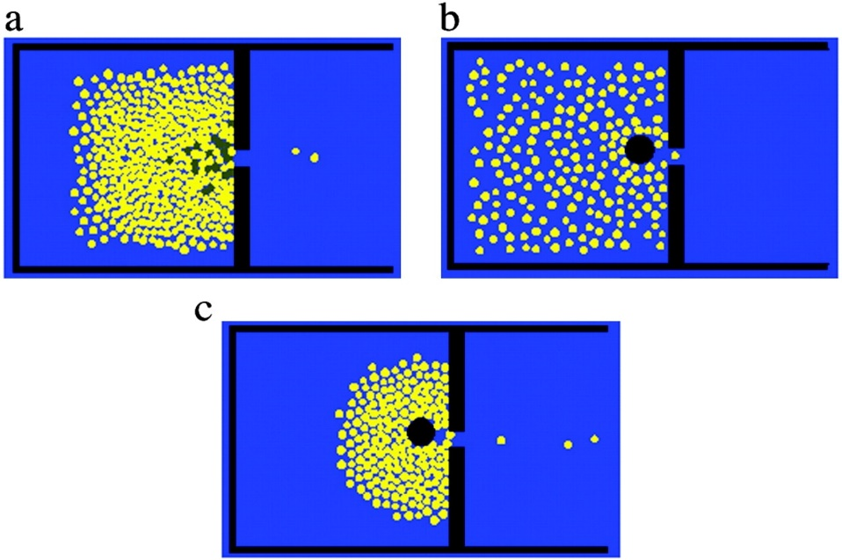

Prototype of project

# (initial design)

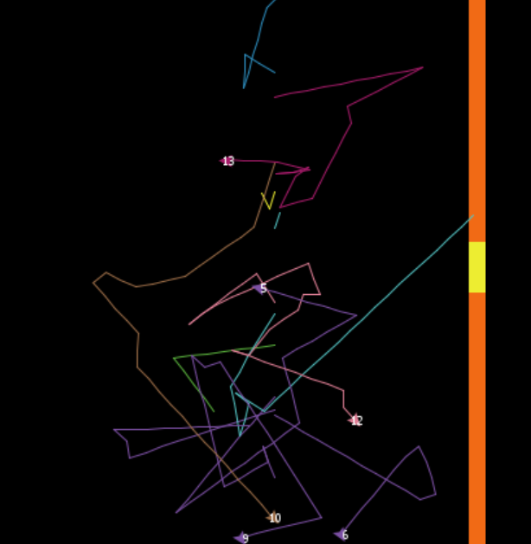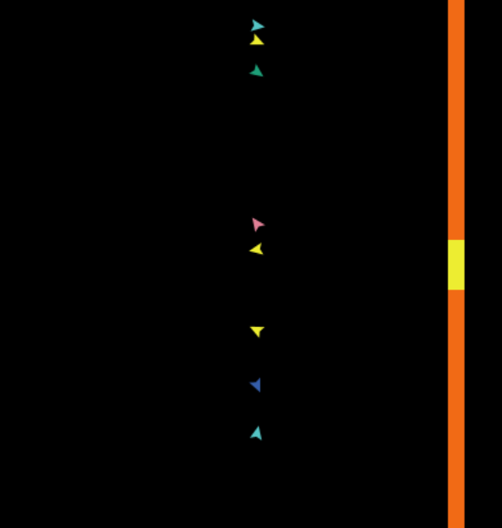

1. Orange color patch is the barrier that separates the environment into two segments
2. On the setup all the agents will be randomly located on the y-coordinate
3. Each agent is represented by a different color arrow and their movement is pen-down
4. All the agents are free to move in any direction
5. agents that collides with the orange barrier gets a label “looser” and dies
6. any agent that crosses the yellow patch gets a label “winner”
7. agents that collide with each other within a close radius dies so they must avoid that
8. so far, no thinking or avoiding techniques are applied in the program its so far in its initial stage
9. initially there are 15 agents on which we are experimenting